CHAPTER 1

**INTRODUCTION**

**Introduction**

This is gym website project, where we aim to provide a comprehensive online platform for fitness enthusiasts. The goal is to create an engaging and personalized user experience that motivates users to achieve their fitness goals. With the increasing demand for online fitness resources, we aim to provide a one-stop-shop for gym enthusiasts, whether they are beginners or advanced fitness enthusiasts. The gym website will offer a wide range of features, including personalized workout plans, nutrition guidance, and access to experienced personal trainers. also aim to create a community for users, where they can connect with like-minded individuals, share their experiences, and provide support and encouragement to each other.

The rising trend of online fitness resources, there is a growing demand for a comprehensive online platform that provides fitness enthusiasts with all the tools and resources they need to achieve their goals. A gym website can help bridge the gap between fitness enthusiasts and gym owners, providing a platform for them to connect, share experiences, and achieve their fitness goals. By creating a personalized and engaging user experience, gym websites can attract and retain users, build a loyal community, and generate revenue for gym owners at the heart of the website is the desire to provide an intuitive and user-friendly platform. Understand that navigating through a website can be challenging, so we have designed the website to be easy to use and navigate.

In this project committed to providing a unique and comprehensive online fitness experience. The website is designed to help to the users achieve their fitness goals while providing a supportive community for them to thrive in. We are excited to embark on this journey with you and look forward to helping you achieve your fitness goals. The project is a website portal, that help users to join our fitness gym. Users can Sign up and log in the website and select suitable membership package according to their need. Regular physical activity is one of the most important things you can do for your health. Being physically active can improve your brain health, help manage weight, reduce the risk of disease, strengthen bones and muscles, and improve your ability to do everyday activities. The gym workout is more beneficial than workout at home. A gym workout will make you a more productive person in every way, like physical, psychological, and social.

.

**1.2 Need**

In today's fast-paced world, where health and fitness have become paramount, the need for a gym website has never been greater. A gym website serves as an essential tool for gym owners and members alike. For gym owners, a website provides a platform to showcase their facilities, services, and trainers. It allows them to create a strong online presence, reach a wider audience, and attract new members. A gym website can also be used to communicate important information such as class schedules, special events, and membership details, making it easier for members to stay updated and engaged.

For gym members, a website offers convenience and accessibility. It allows them to browse through the gym's offerings and make informed decisions about their fitness journey. With a gym website, members can easily access class schedules, book sessions, and even track their progress. It also provides a platform for community building, where members can interact, share their experiences, and support each other in achieving their fitness goals. Overall, a gym website is an indispensable tool that bridges the gap between gym owners and members, providing a seamless and efficient experience for everyone involved.

CHAPTER 2

**Literature Survey**

**Literature Survey**

With the increasing demand for online fitness resources, gym websites have become an essential tool for fitness enthusiasts, gym owners, and entrepreneurs looking to venture into the fitness industry. This literature review aims to explore the current state of research on gym websites, their impact on the fitness industry, and their effectiveness in engaging users.

* Choi et al. [1]: Choi and colleagues conducted a study that focused on the significance of website design in engaging users on gym websites. Their research aimed to identify the key factors that contribute to user satisfaction and engagement on such platforms. Through data collection and analysis, they found that a clean and intuitive website design, easy navigation, and relevant content were crucial for engaging users and increasing their satisfaction levels. The study emphasized the importance of creating an appealing and user-friendly website interface to enhance the overall user experience.
* Joo et al. [2]: Joo and his team explored the impact of social media integration on gym websites. Their research aimed to investigate how incorporating social media elements into gym websites influences user engagement and generates leads for gym owners. The study revealed that integrating social media platforms into gym websites resulted in increased user engagement and higher lead generation. The researchers suggested that gym websites should also incorporate interactive features, such as fitness challenges and online communities, to further enhance user engagement and retention.
* Eom et al. [3]: Eom and colleagues conducted a study focusing on the effectiveness of gym websites in attracting and retaining gym members. Their research aimed to identify the features and content that contribute to member retention. The study found that gym websites offering personalized content, such as customized workout plans and nutrition guidance, were more likely to retain members compared to websites that lacked such features. These findings highlight the importance of providing tailored content and services to enhance member engagement and satisfaction.
* Batacan et al. [4]: Batacan and co-authors presented a survey paper that provides an overview of gym management systems (GMS) and their features. Their study aimed to provide a comprehensive understanding of GMS and the potential benefits they offer to gym owners and managers. The authors examined various aspects of GMS, including membership management, scheduling and booking, and reporting, shedding light on the functionalities and advantages these systems bring to gym operations.
* Thompson et al. [5]: Thompson and colleagues discussed key features of gym management systems in their paper. The authors focused on aspects such as membership management, which involves tasks like member registration, tracking, and communication. Additionally, they explored other functionalities, including scheduling and booking features, as well as reporting capabilities. Their research provides insights into the functionalities and benefits of using a gym management system for effective and streamlined gym operations.
* Paterson et al. [6]: Paterson and co-authors examined the challenges associated with the adoption of gym management systems (GMS). Their paper discusses various obstacles that gym owners and managers may encounter when implementing GMS, including cost considerations, technical expertise required for implementation, and data security concerns. By highlighting these challenges, the authors provide valuable insights for decision-makers who are considering the adoption of GMS in their gym facilities.
* Rebar et al. [7]: Rebar and his team presented a paper that suggests potential areas for future research in the field of gym management systems (GMS). They highlight the need to explore the impact of GMS on gym performance and the potential for these systems to enhance member engagement. The authors propose these as areas for further investigation to expand the understanding of GMS and their implications in the fitness industry.

CHAPTER 3

**Proposed System**

**Proposed System**

**3.1 Problem statement: -**

**To Replace the cluttered design, poor navigation, and outdated content of the existing gym websites.**

The proposed system for a gym website aims to provide a comprehensive and user-friendly platform that enhances the overall gym experience for both gym owners and members. Firstly, the website will have a robust membership management system. It will allow individuals to sign up for memberships, select their preferred plan. The system will also have features to track membership expiration dates and provide seamless online membership management options.

Secondly, the proposed system will include an interactive class scheduling feature. Gym members will be able to view the class schedule, check availability, and easily book their desired classes through the website ensuring that members never miss a session. Additionally, the website will provide detailed information about each class, including the instructor, duration, and intensity level, empowering members to choose the classes that align with their fitness goals.

Lastly, the proposed system will incorporate a personalized fitness tracking and progress monitoring component. Members will have access to their individual profiles, where they can track their workout history, set goals, and monitor their progress over time.

**3.2 Objective: -**

The objectives in a gym website project can vary depending on the specific goals and requirements of the project. However, here are some common objectives that a gym website project may aim to achieve:

* Increase Online Visibility: Improve the online presence of the gym by creating a professional website that ranks well in search engine results and attracts organic traffic.
* Attract and Convert Potential Customers: Generate leads and convert website visitors into gym members by providing compelling information about the gym's services, facilities, classes, and membership options.
* Enhance Member Engagement: Provide a user-friendly and interactive website that engages existing gym members through features like class schedules, member profiles, fitness tracking, community forums, and social media integration.

**3.3 Scope: -**

The scope of a gym website encompasses the various functionalities and features it will offer to meet the needs of the gym and its users. The scope can be defined as follows:

The gym website will serve as an online platform for promoting the gym's facilities, services, and trainers. It will provide detailed information about the gym's equipment, workout areas, group classes, personal training options, and any additional amenities. The website will feature an intuitive user interface that allows visitors to easily navigate through the pages and find the information they need. It will include a membership management system that allows individuals to sign up for memberships, select their preferred plans.

The website will also provide a class scheduling feature, enabling members to view and book classes conveniently. Additionally, the website will offer a member portal where members can access their profiles, track their progress, communicate with trainers, and engage with other members. The scope of the gym website will also include regular updates and maintenance to ensure accurate and up-to-date information. Overall, the gym website will aim to enhance the online presence of the gym, attract new members, and provide a seamless and engaging experience for both potential and existing members.

**Advantages: -**

* Increased Online Visibility
* 24/7 Accessibility
* Showcasing Facilities and Services
* Online Membership Management
* Class Scheduling and Booking

**3.4 Block Diagram**

**Fig: Block Diagram of Telecom Billing System**

|  |  |  |
| --- | --- | --- |
| **SR. NO.** | **Name of Blocks** | **Description** |
| **1.** | Add New Records | For the add new billing records, the user can add new billing records details. |
| **2** | **List of Records** | For the list of billing records, the user can view all the new billing records added. |
| **3.** | **Payment** | For the payment, the user can pay their telecom billing in this system. |
| **4.** | **Search records** | For the search billing records, the user can search through their phone number. |
| **5.** | **Edit Records** | For the edit records, the user can edit billing records information. |
| **6.** | **Delete Record** | For the delete billing records, the user can delete their own billing records information. |

**3.5 Flow Chart: -**

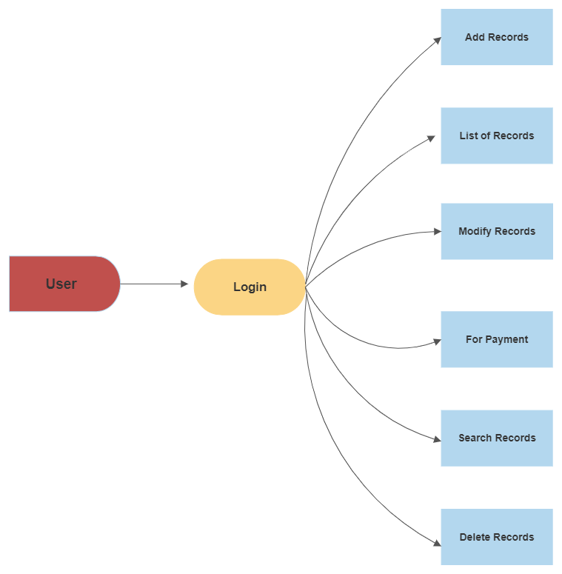

In this Telecom Billing Software, first user login it by entering User Name & Password. After that user enter to Home Page, user can see number of options has shown in above flowchart.

CHAPTER 4

**System Requirements**

**System Requirements**

**4.1 Hardware Requirements Details: -**

Hardware is a set of physical components, which performs the functions of applying appropriate, predefined instructions. In other words, one can say that electronic and mechanical parts of computer constitute hardware.

* RAM: 500MB MINIMUM
* HARD-DISK: 500MB MINIMUM

**4.2 Software Requirements Details: -**

The software is a set of procedures of coded information or a program which when fed into the computer hardware, enables the computer to perform the various tasks. Software is like a current inside the wire, which cannot be seen but its effect can be felt.

* OPERATING SYSTEM: WINDOWS 7 OR HIGHER
* SOFTWARE: VS Code/ Dec C++ (Text Editor)
* Language Used: C++

CHAPTER 5

**Implementation**

**Implementation**

**5.1 Activity Diagram**

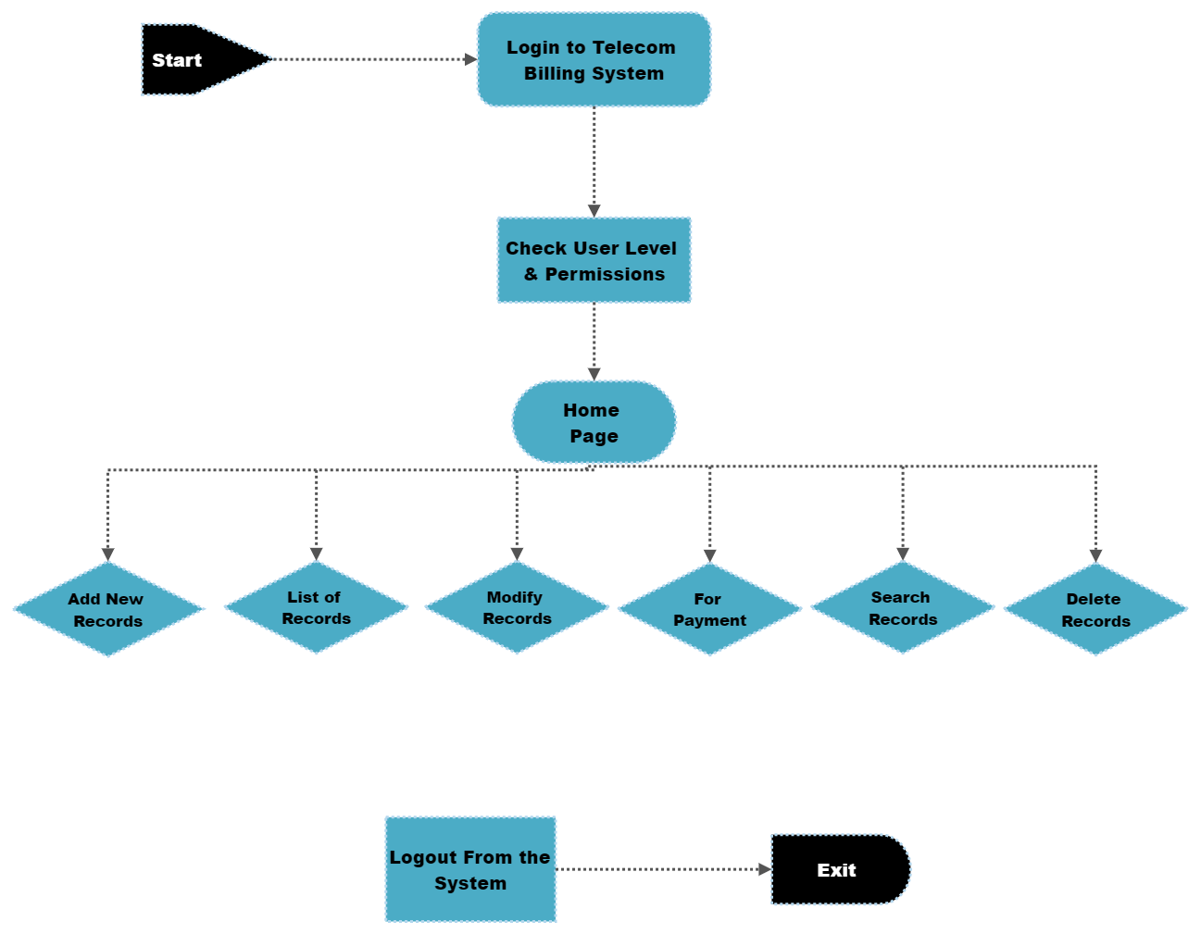

**Fig: Activity Diagram of Telecom Billing System**

**5.2 Data Flow Diagram**

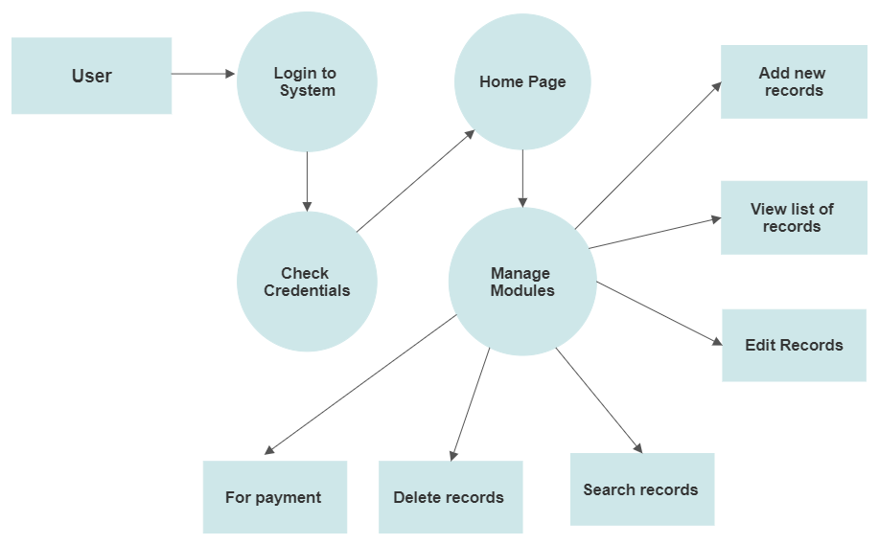

**5.3 Sequence Diagrams**

**1)**

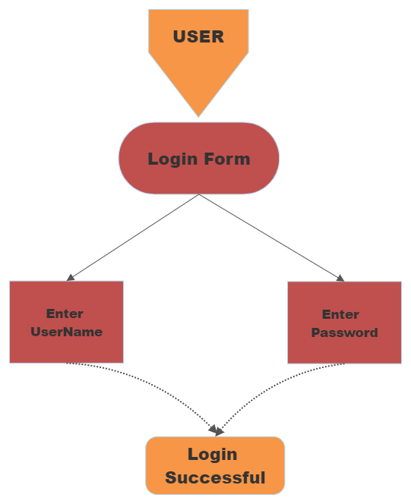

In this telecom billing software, the first user enters the login page Here the user has given the username and password after that the user can see they have login successfully. As shown in above sequence diagram.

**2)**

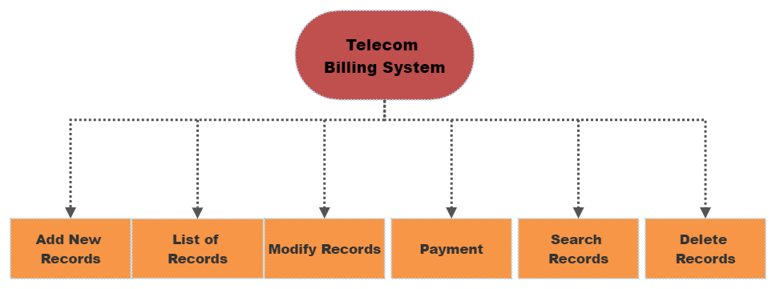

After login page user can see home page here user can see number of options (as shown in above diagram), user can choose any of them as per there requirements

**3)**

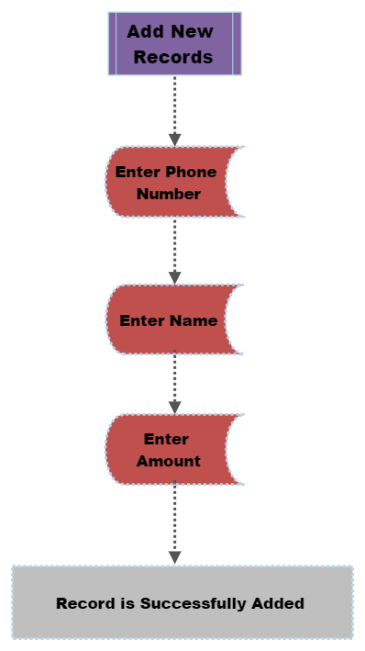

After that suppose the user wants to Add new record then by entering the phone number, name and amount the user can add their record successfully.

**4)**

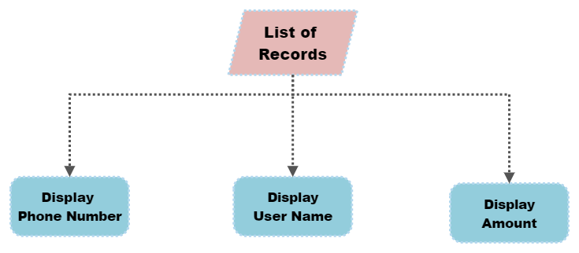

Now, if the user wants to see the list of their records, then the user can see it by visiting list of record over there the user can see there previously added records with phone number, name and the amount to pay.

**5)**

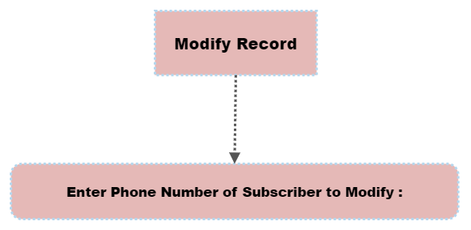

If any of the user wants to modify the added record then the user can modify it by visiting 'modify record' here the user has to enter the phone number of record to modify after that they can do any changes as per there requirements i.e., the user can modify their record easily.

**6)**

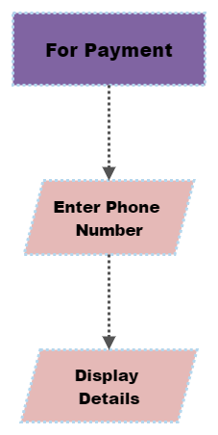

Now, if the user wants to do payment, then the user can choose ‘for payment' after that the user have to enter their phone number now, the user can see their detail i.e., the user phone number, name and amount to pay now the user can enter the amount which they want to pay. This makes the user to do payment easily**.**

**7)**

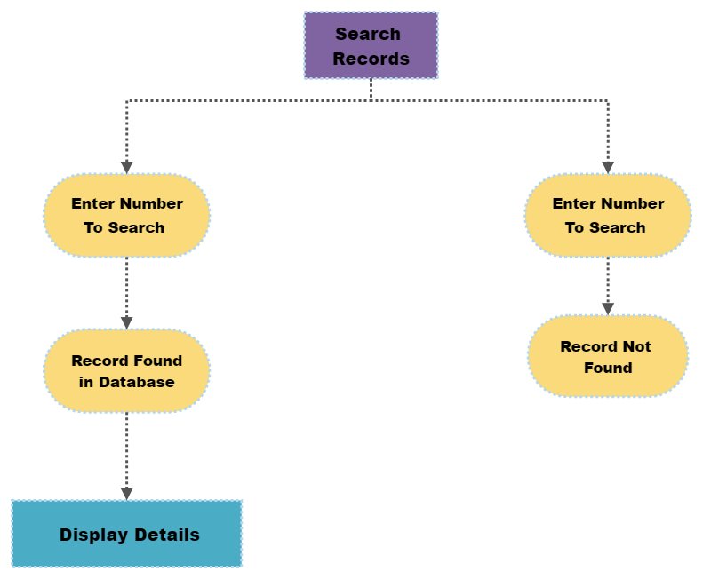

If the user wants to search any of their record, then by visiting the 'search record ' the user can search their record by entering their phone number then if the record is present then it will display the search record and if not present the record not found will be display. By using this the user can search any of the record fast and easily.

**8)**

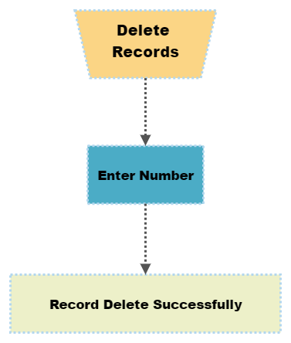

Now if the user wants to delete any of the record which is not useful then by visiting 'delete record' the user can delete the record by entering the phone number hence by entering phone number the user can delete their record successfully. This makes the user to work easily.

**5.3 Snapshots: -**

**Login Page**

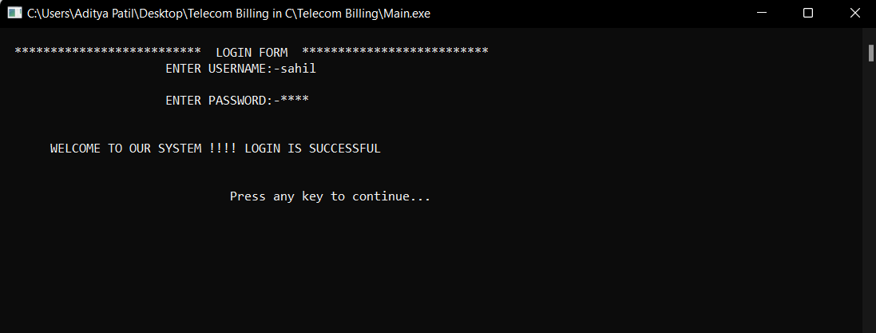

**Login Page**

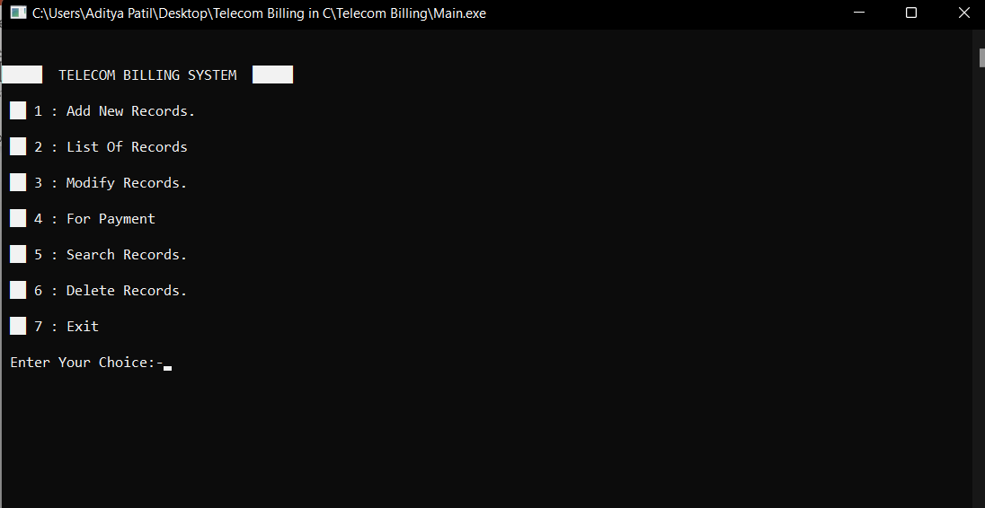

**Add New Record**

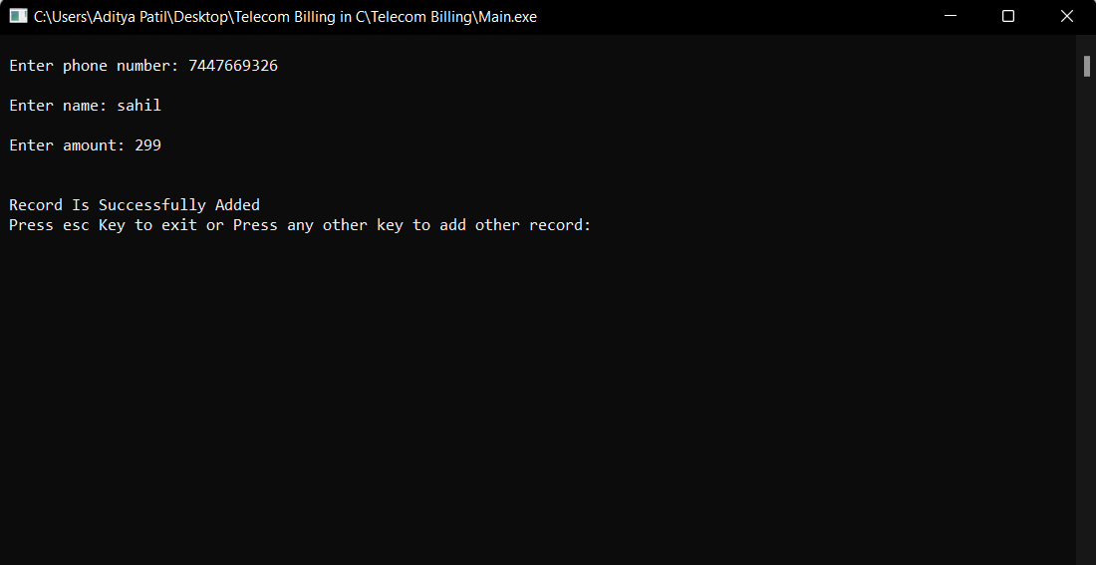

**List Of Records**

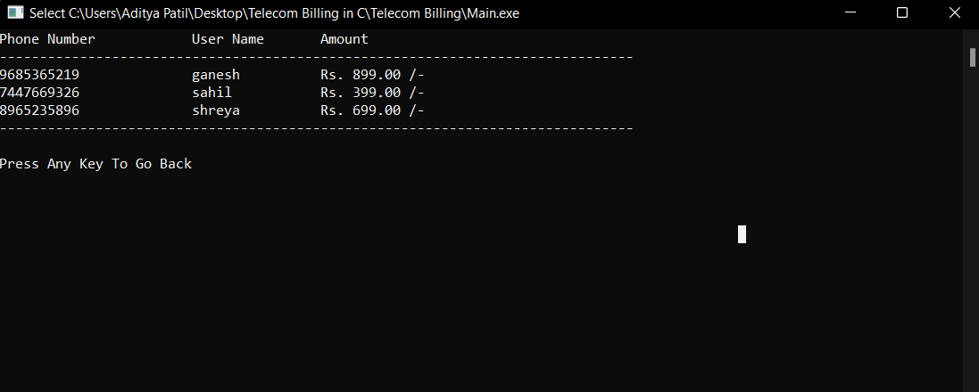

**Modify Records**





**For Payment**



**Search Records**





**Delete Records**



CHAPTER 6

**Future Work**

**Future Work**

Development in the telecom industry in the late 1990s gave rise to the demand of efficient billing system. But it is during last few years that billing system have received importance equivalent to other facets of telecom sector. Complexity related to mobile device technology and pricing have also paved the way for a robust system to meet the needs of the present digital era. Billing solution providers from across the globe have constantly added multiple features in their solutions to make sure both consumers and telecom operators do not face any billing related issues

* Availability of itemized bills.
* High accuracy in billing.
* Instant information available to call center agents.
* Paperless bill generation.
* Customer Data safety.
* Reduce material costing that come with manual billing and filing.

CHAPTER 7

**Conclusion**

**Conclusion**

This telecom billing software is an advance billing software which consist of tools capable to manage the data of large number of customers. This project is developed to nurture the needs of user in telecom billing system by embedding different type of operation which are useful in telecom billing sector. This telecom billing system can prepare bill and can generate it quick as flash This telecom billing system provide enormous benefits to the user working with this software helps the user to fast and easily.

The previous impossible process with manual system is now possible with this software. Since this project is designed to make it simple and quick to complete. Telecom billing system is highly secure with advanced technology to keep customer details safe and secure. Future version of this project will still be much enhanced that than the current version. This telecom billing system save time and also accurate in work than the manual system.

**References: -**

Dr. Geeta Sharma, “Study of Telecom Billing Scenario in India”, International Journal of Emerging Research in Management &Technology, ISSN: 2278- 9359, Volume 5, Issue 5, 2016, pp.43-48.

Anju Dagar, “Telecom Billing: Benefits and Related Issues”, International Journal of Commerce, Business and Management (IJCBM), ISSN: 2319– 2828, Vol. 3, No. 5, 2014, pp.715-719.

Ebubeogu Amarachukwu Felix, “Customers Management System”, International Journal of Scientific & Technology Research Volume 4, Issue 08, 2015, pp.326- 343

**Reference sites: -**

<https://www.invoicera.com/blog/billing-software/major-challenges-chopping-chords-for-telecom-billing-companies/>

<https://www.onebillsoftware.com/blog/5-best-features-of-billing-and-invoicing-software-for-telecom/>

<https://timelybill.com/how-is-telecom-billing-done.html>

<https://www.jerasoft.net/blog/benefits-of-telecom-billing-software/>

<https://www.matellio.com/blog/12-benefits-of-telecom-billing-software/>